



**L2AI4 Code Management with VCS**

**Submission: Final Submission**

**Academic Semester: Summer class 2025**

|  |  |  |  |
| --- | --- | --- | --- |
|  | **Group Name: WeCare** | |  |
| **SN** | **Student Name** | **College ID** | **University ID** |
| **1** | **Erick Pradhan (AI4) (Leader)** | **NP01AI4A240097** | **24046582** |
| **2** | **Niraj Shrestha (AI4)** | **NP01AI4A240114** | **24046603** |
| **3** | **Surya Narayan Yadav (AI4)** | **NP01AI4A240093** | **24046654** |
| **4** | **MD Rashid Fazeel (AI4)** | **NP01AI4A240099** | **24046597** |
| **5** | **Bikash Raj Chaurasiya (AI4)** | **NP01AI4A240106** | **24046575** |

**Assignment Due Date: Sunday, August 24, 2025**

**Assignment Submission Date: Sunday, August 24, 2025**

**Word Count: 1077**

**Submitted to: Mr. Prithvi Maharjan**

*I confirm that I understand my coursework needs to be submitted online via MST Classroom under the relevant module page before the deadline in order for my assignment to be accepted and marked. I am fully aware that late submissions will be treated as non-submission and a mark of zero will be awarded.*

**Table of Contents**

Overview 1

Team roles 1

Git activities with screenshots 2

Summary of git commands used 5

Merge conflict documentation 6

Team contribution breakdown 7

Reflection on GitHub usage 8

**Table of figures**

Figure 1: overview of GitHub 2

Figure 2: pull request 3

Figure 3: merging 3

Figure 4: commits 4

Figure 5: merge conflict 6

**Table of tables**

Table 1: Team contribution list 7

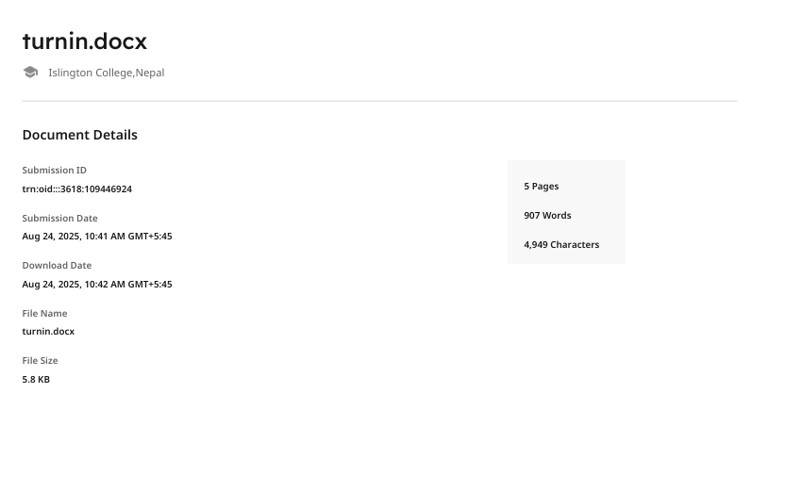

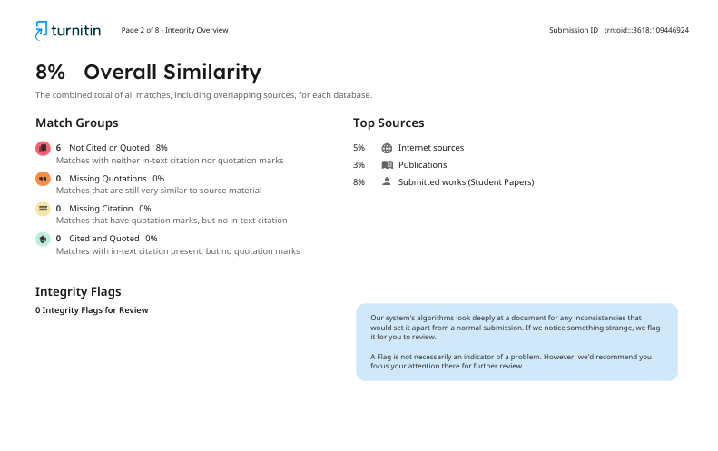

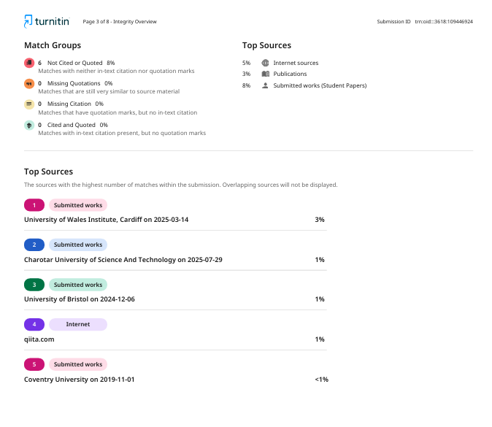

# **Overview**

WeCare is designed as a digital marketplace that brings customers and trusted local service providers together in one convenient platform. Whether someone needs a plumber, electrician, beautician, doctor, therapist, or tutor, WeCare makes it easy to search, compare, and book services quickly and reliably. At the same time, it gives professionals a place to showcase their skills, manage appointments, and receive secure payments. By focusing on trust, transparency, and simplicity, WeCare makes everyday life easier for customers and helps service providers grow their business.

The platform goes beyond just booking services. With verified profiles, ratings, and reviews, customers can feel confident they are choosing reliable professionals. Service providers benefit from tools to manage their schedules, communicate with clients, and expand their reach. Ultimately, WeCare creates a community where both customers and providers can connect seamlessly, saving time, reducing stress, and ensuring quality service for everyone.

# **Team roles**

1. Team leader – Erick Pradhan

Oversaw the whole project, gave everyone tasks and made sure those tasks were being fulfilled. Coordinated the communication between all the team members. Helped in backend code of the project.

1. Fronted development – Bikash Raj Chaurasiya & MD Rashid Fazeel

Designing and making all the project by implementing HTML, tailwind CSS, and JavaScript. They made sure that the platform is interactive and user friendly.

1. UI/UX designing and documentation – Niraj Shrestha & Surya Narayan Yadav

Created wireframes and visual layouts for the website to make sure that the website looks appealing. Making the project documents like the presentation, logbooks, etc.

# **Git activities with screenshots**

Some activities recorded with using GitHub with their screenshots:

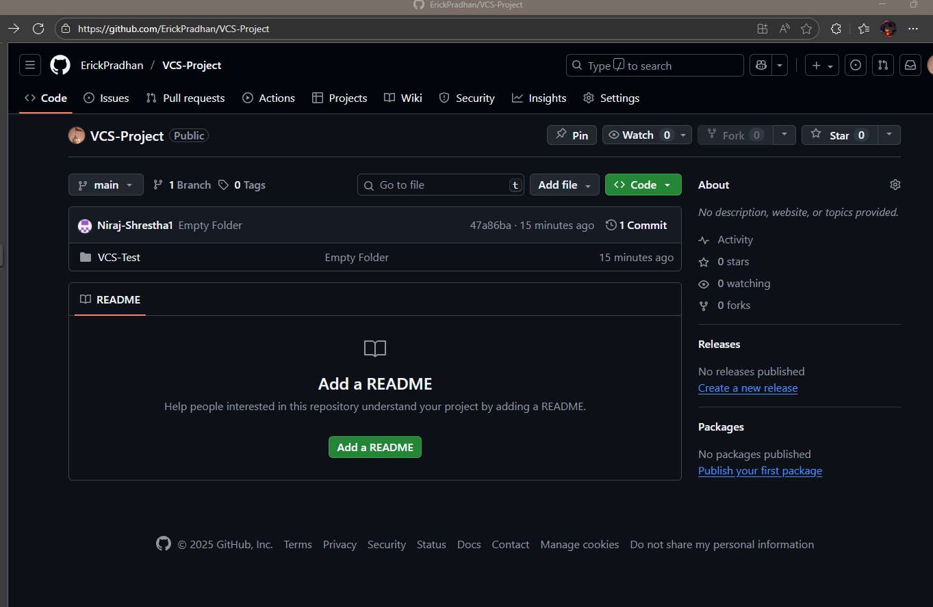

Figure 1: overview of GitHub

The above image shows the main page of the GitHub repository that was used. This has every folder to be created and it is displayed in this page.

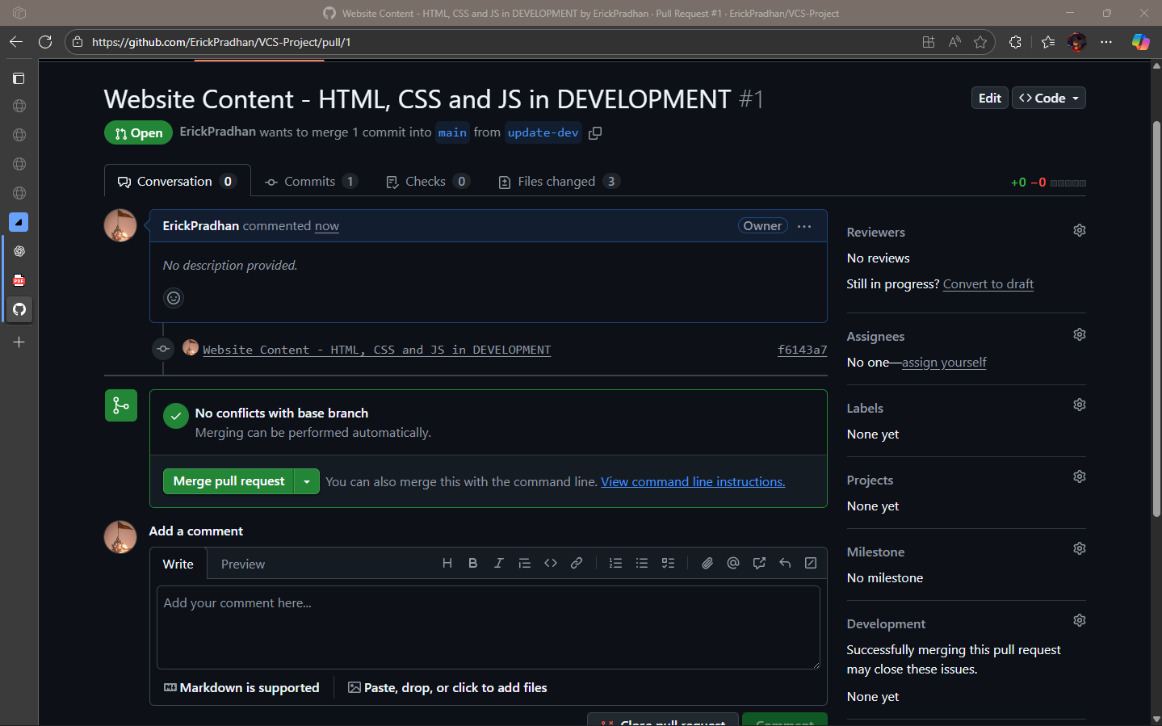

Figure 2: pull request

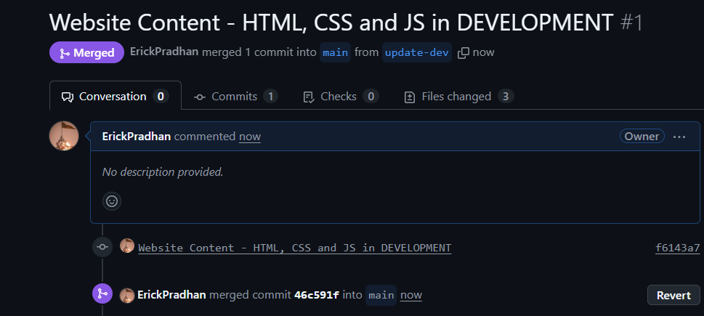

Figure 3: merging

The above given images show pull requests and merging documents in GitHub.

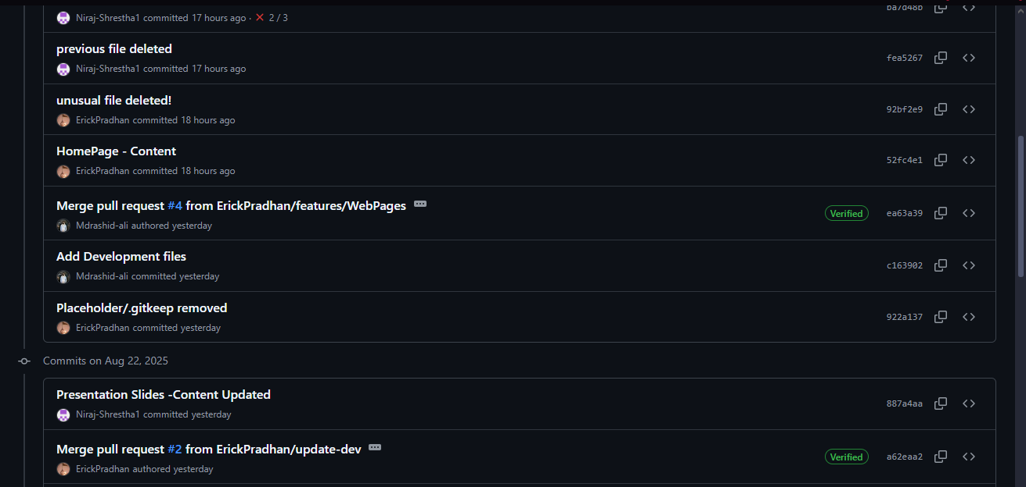

Figure 4: commits

The above image shows some commits made by our group members.

# **Summary of git commands used**

Git init – used to initialize the repository.

Git clone <url> - used to make a clone of the repository in to your laptop.

Git config –global user.name <github user name> - Makes record of you in github to know it id you by your name.

Git config –global user.email <github user email> - Makes record of you in github to know it is you by your email.

Git add <file> - new or modified files for the next commit

Git commit –m “message” – saves changes with a message

Git status – shows all the changes happened

Git checkout <branch> - switches to another branch in guthub.

Git merge <branch> - combines the changes of of branch into current one

Git pull – Fetches changes from a remote repository and merges them into the current branch.

Git push – uploads local commits to the repository in guthub.

Git log – shows all the commit history.

Git rm <file> - removes a file and stages the deletion for commit.

# **Merge conflict documentation**

A merge conflict occurs when two different people or branches have made different changes to the same file and GitHub cannot decide which changes to keep while which changes to discard while merging the whole operation. It will send out an error which is called a merge conflict.

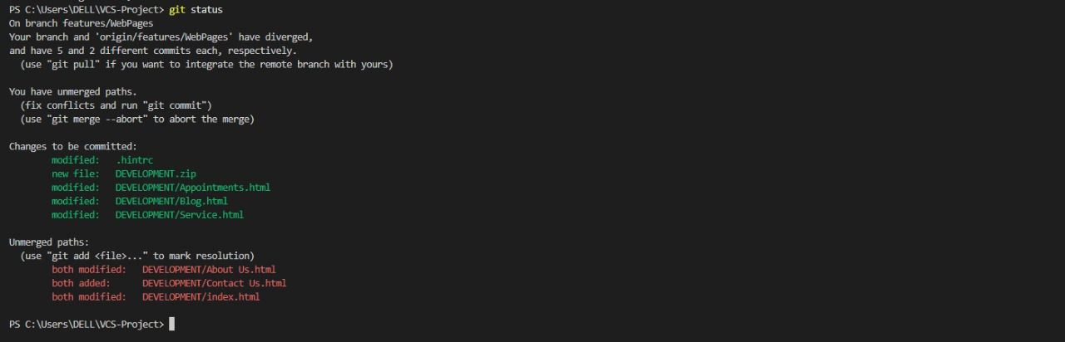

Figure 5: merge conflict

The above image shows an error while having to merge a.k.a a merge conflict.

The problem occurred while merging the features/WebPages branch, conflicts came up in three HTML files. After looking through all the files, cleaning up the conflicting sections, kept the right changes, and saved them. After that, the fixes were staged and commited and then pushed into GitHub. The merge finished nicely with no errors after.

Merge conflicts are a pretty normal part of collaborative GitHub work. In this case, the conflicts were easily resolved with not much hassle.

# **Team contribution breakdown**

|  |  |  |
| --- | --- | --- |
| **Name** | **Contribution** | **Contribution (%)** |
| Erick Pradhan | **Contribution:** Task assigning, GitHub conflict handling, Homepage development.  **Application Implementation:** Built homepage layout and booking integration | 20% |
| Bikash Raj Chaurasiya | **Contribution:** Blog & form pages, header/footer, navigation bar, bug fixes.  **Application Implementation:** Styled booking form and interactive components. | 20% |
| MD Rashid Fazeel | **Proposal:** Conclusion, Appendix  **Application Implementation:** Setting the Arduino IDE and designing the prototype, debugging and reviewing the code. | 20% |
| Niraj Shrestha | **Contribution:** Documentation, presentation, CV & feedback forms, policies.  **Application Implementation:** Assisted coding forms and project documentation. | 20% |
| Surya Narayan Yadav | **Contribution:** Wireframes, logbook, project descriptions.  **Application Implementation:** Focused on UI/UX flow and documentation content. | 20% |

Table 1: Team contribution list

# **Reflection on GitHub usage**

Using GitHub for this project helped us manage our work and keep everything organized. It allowed everyone in the group to work on different parts at the same time without overwriting each other’s changes. The use of commits, branches and pull requests made it easier to track the progress and know who had done what.

We also faced merge conflicts during the process, but by carefully checking the files and fixing the conflicts, we were able to solve the problem. This showed us how important it is to communicate with each other and commit regularly so that the conflicts do not get bigger.

Overall, GitHub made our teamwork smoother and more reliable. It gave us a safe place to store our code and history, and we learned how useful it is in collaborative projects. By the end, we felt more confident using Git commands and GitHub for managing and completing group work.